**“Git Bash (CMD Codes)”**

**Check Version of Git. (Installed or Not?)**

* git --version
* git config --list

**TO Set Name & Email**

* git config --global user.name "/Username-Here/"
* git config --global user.email "/Useremail-Here/"
* git config --global --edit

**TO get Name & Email**

* git config --global user.name
* git config --global user.email

**To Initialize git in to your current repository**

* git init
* git add **.**
* git reset **.**
* git add "single file name here."
* git status

**Tip: Git will also ignore files & folders**

* If we just put their name in .gitignore file.

**To Commit**

* git commit -m "Message will type here"
* git log (*What we have do will showed.)

**To add & commit in a single command.**

* git commit -a -m "Message will type here"

**Tip for VS Code:**

* There is a Graphical Interface that can allow us to commit or add or do anything that we do by using bash cmd.
* "A Tool Git-Lens is also useful in VS Code for Git."

**>> ls -a**

* This will show hidden files like .git & .gitignore

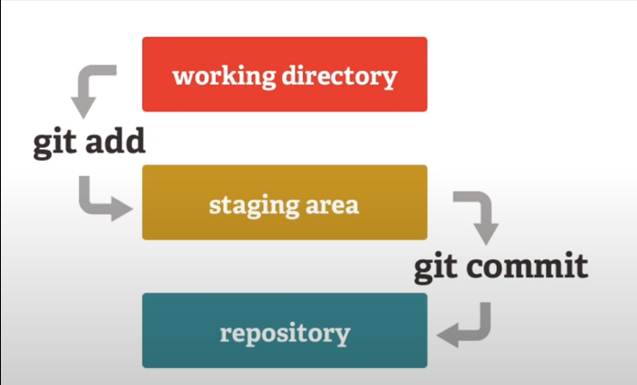

**To Create Branch**

* git branch //this will show all branches
* git branch “new branch name here” // this will create new branch.
* git checkout new-branch //this is use to switched to new branch

**Directly Create & Switched to new branch**

* git checkout -b new-branch

**Switched to any commit**

* git checkout hash-Code-Here

**Merge two branches**

* *//Select the parent/master branch of the child branch => (which is about to merge with master branch).*
* git checkout master-branch
* git merge child-branch

**To ADD & Restore file/Directory**

* git add . //to add all the untracked files into staged position.
* git restore --staged file-name

**To rename a branch**

* git branch -m new-name-of-branch

**To Push Directory to GitHub Repository**

* // go to your GitHub account and select to create a repository.
* // get a https:// from there.
* // Now open your directory in local computer in VS Code
* // Open the terminal and init the Git there
* git init
* git add .
* git commit -am “New Files added”
* git remote -v // check do we have any remote version.
* git remote add origin(or any name) https:// “paste the copied URL here”
* git branch -m master
* git push -u origin master

**To Fork a Repository**

* There is a button in the repository which we want to fork then we just click and select our account.
* This will make a copy of their project into our account.
* Then we can just clone/pull it from our account to local account.

**To clone a Repository**

* Get link of the cloning repository then just do it
* git clone “paste link here”
* Now you can perform your task at your local

**To Add a contributor**

* We also have a button to add a contributor in our project who have full access to our project and can also modify our project.

**Source:**

[**(65) Learn complete Git and Github in 1 video | Open-source Contribution | Linux commands & tricks - YouTube**](https://www.youtube.com/watch?v=uaeKhfhYE0U)